|  |  |
| --- | --- |
| **JDBC & SERVLETS**  **NAME: _________ TIME : 90 MINS** | **Test Objectives**   * *Basic understanding of JDBC* * *To understand the Servlet* |

**MARKS OBTAINED: ____ / 50**

**GRADE _____**

1. **Fill in the Blanks (20*1=20)**
2. Data base is a collection of _____________.
3. __________ are used by Java applications to communicate with database servers
4. Microsoft established a common standard for communicating with databases, called ODBC it stands for___________________
5. Type -1 driver is called as _______________________________________
6. Java Soft created the _____________ driver as a temporary solution to database

Connectivity until suitable JDBC drivers was developed.

1. ______________consists of pure Java drivers that speak a standard network protocol (such as HTTP) to a database access server.
2. ____________ provides a common database-programming API for Java programs.
3. The ___________________ class is responsible for loading and unloading drivers.
4. ___________ Method defined in the HttpServletResponse class that may be used to set the content type.
5. When a statement object is send to the database, the database runs the SQL and returns a ______________
6. A Statement object is created using the __________________ method in the Connection object.
7. The return type of executeQuery() method is _____________________.
8. The return type of executeUpdate () is ____________________
9. The number of ResultSet(s) returned by executeQuery () is ____________________.
10. executeUpdate() method can execute ______________ methods of SQL.
11. The servlet API contains _________________ and _____________________ packages.
12. CGI stands for ________________________________________
13. Servlets can also very easily handle POST requests, which are generated when someone creates an HTML form that specifies METHOD="______________________” .
14. doGet or doPost() method takes __________________ and __________________arguments.
15. MVC stands for ____________,___________________& _____________________.
16. GenericServlet is an _______________
17. ___________ is responsible to create a servlet instance.
18. Web.xml is also called as __________________________
19. HTTP stands for_____________________________
20. By default tomcat runs on ___________ port
21. 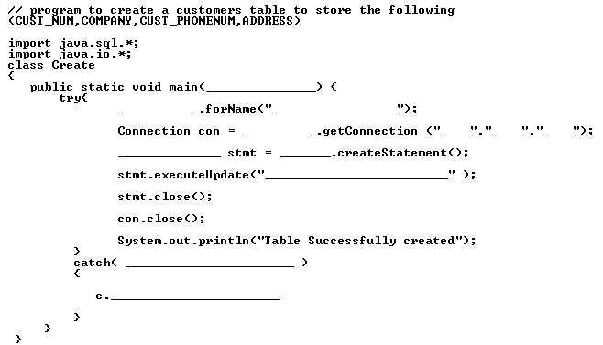**Complete the following Program (5 * 3 =15)**

**1**

**2. Complete the following code to Select the rows from the above created table**

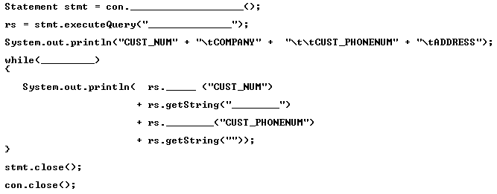

1. Write a JDBC Application to select a record based on emp id and delete a record also based on empid.
2. Write a JDBC program to demonstrate a PreparedStatement.
3. Write a JDBC Program to demonstrate CallableStatment.

**III. ANSWER ANY 5 OF THE FOLLOWING (5*3=15)**

1. How to get JDBC connection?

2. How can you implement JDBC?

3. How do you retrieve result?

4. Write steps to create a Web application and Tomcat directory structure.

5. Explain prepared statements and Callable statements.

6. GET V/S POST

6. Servlet Life Cycle